

Simulation Project 5

EML 6351

by

Aahlad Vanam

13681791

**Dynamic model:** 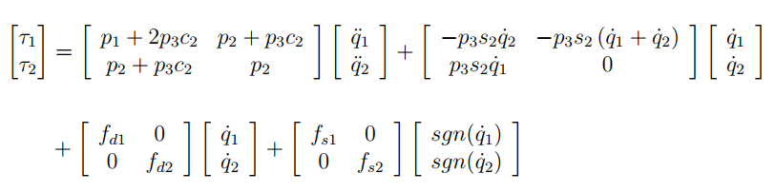

This is in the form of $= m\left(q\right)\ddot{q}+V_{m}\left(q,\dot{q}\right)\dot{q}+F_{d}\dot{q}+F_{s}sgn(\dot{q})$-----------------------(1)

(b) Problem definition and open-loop error system development:

Open Loop error system: $e = q – qd$

(c) Control design (including adaptive update law) and closed-loop error system development:

=

**RLC:**

 =

3) Simulation Section:

**Standard Adaptive Controller**

1. Control Gains used:

K = 40

a = 0.5

gamma =

40.0000 0 0 0 0 0 0

0 10.5000 0 0 0 0 0

0 0 0 0 0 0 0

0 0 0 40.0000 0 0 0

0 0 0 0 5.0000 0 0

0 0 0 0 0 0.0010 0

0 0 0 0 0 0 0.0001

1. Tracking Error Plot:



1. Control input plot:



1. Plot of the adaptive estimates:



1. Plot of Parameter estimate errors:



**Repetitive learning controller:**

1. List of Control Gains:

gamma =

0.4000 0

0 0.4000

K = 40

K1 = 40

K2 = 40

a1 = 0.4

beta = 0.4

1. Tracking error plot for each link:



1. Control input plot for each link:



1. Plot of the adaptive estimates:



1. Plot of the repetitive learning term:



1. **Discussion Section:**
2. Tuning adaptation gains had the most effect on the convergence of errors, control gains were tuned in order to improve the performance of the controllers. However, the gains corresponding to friction terms in gamma can be reduced to yield better results.
3. Performance of tracking error is higher in RLC as compared to standard. Although neither of them is damped enough, RLC remain closer to zero than Standard adaptive one.  
    

We observe the errors bounce around zero at an average magnitude of 0.1 for Standard adaptive where they go as high as 0.03 giving better tracking performance.

1. Performance of adaptation for each case:



Standard Adaptive



RLC

From the above graphs we see that adaptive estimates performance did not improve a lot with RLC, a different set of gains can be used to improve its performance however they make the controller go out of bounds.

Other Observations:

* The simulated performance resembles to the theoretical one.
* The spikes in controller plot is due to the discontinuities in the ode45 solver which is further compounded by using a discontinuous function like sgn(). Other than those spikes, controller remains bounded and performs better than standard adaptive controller using lesser torque in comparison
* To achieve this performance for RLC controller we needed 10.3% of max torque for link 2 (ignoring the spikes) and 1.6% of max Torque for Link 1(ignoring the spikes).

In comparison to RLC, standard controller has higher number of spikes and requires more torque than RLC.

* In terms of computational effort, RLC and standard adaptive run for similar time with RLC being a bit faster.
* Some steady state error is seen in the controller; however, this controller ran without knowing the physics of the system. Therefore, we can safely use RLC for an unknown system with an expectation of a good tracking.